**Introduction**

Zircoa’s Preweigh department currently serves as both a processing department, (producing preweigh batches) and an inventory warehouse. During a recent evaluation, it was proposed that we would see a processing improvement by separating most warehouse functions away from the department, and moving them instead to an external warehouse. The goal of this analysis was to determine how much space would be required under a supermarket-raw-material model, in place of our current stock-to-safety model.

**Results:**

In the current stock-to-safety model, Zircoa Preweigh designates 264 pallet spaces. This represents approximately 2950 sq. ft. of space designated to inventory stocking. This represents 24.5% of the space available to the preweigh department.

In a two-week/one-week supermarket-raw-material model, Zircoa Preweigh would require 42 spaces for preweigh raw material, with an additional 8 spaces for in-and-out materials. This model would require approximately 560 sq. ft. of space designated to inventory stocking. This would represent 4.6% of space designated to the preweigh department.

**Methods:**

**Current Space Designation**

Spaces were counter in the Zircoa Preweigh area, and included spaces being used, spaces designated for use, and spaces not designated for use, but being used nonetheless.

Spaces being used & spaces designated: 230

Spaces not designated but used: 34

The pallet sizes in preweigh are overwhelmingly (perhaps exclusively) 40” x 40”, and so that was the model used to determine square foot per pallet space: 40*40 = 1600 sq. in./144 (sq. in./sq. ft.) = 11.11 sq. ft. per pallet space. This number was then multiplied by number of spaces required.

**Future Space Designation**

**Future Work Requirement**

**Batches produced per comp per day.**

The first step was to determine what work load would look like under a pull-based system (as opposed to the low-change-over push model used today.) To evaluate this, I worked off of the CGB2.xls (O:/Plant/CGB2.xls) to get a work-requirement benchmark. CGB2.xls shows all the work produced by CGB, and can be separated into dates. To do so, the batch no. must be parsed – Batch no. is laid out as YYMMDDXX, where YY is year, MM is month, DD is day, and XX is a sequential index for the number of batches produced that day. The document was imported into python, and the batch number was parsed to get a date. (Done in cgb2_data_pull.py, under class CGBBatchProduced).

From here, I decided (arbitrarily) to focus on batches made in 2015. With that decision, any composition that was not produced in 2015 was removed from consideration.

**Note:** Batches produced in 2015 – 3077, 3001, 3004, 1968, 1651, 2004, 6105, 2073, 1661, 6101, 2290, 3036.

With this data, the batches could then be counted and placed in a matrix listing the number of a given comp produced in a given day.

Example:

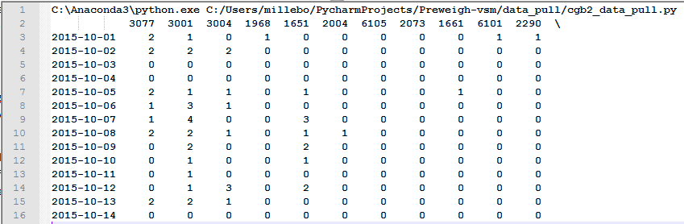

This matrix was built for 2015, from 12/28/2015 (week 1) to 11/22/2015 (Week 48) and used for the rest of the analysis.

**Batches produced per week, per bi-week.**

To evaluate weekly and bi-weekly batch requirements, the above matrix was collapsed into the sum of batches produced in rolling one-week and two-week periods. This was done using a Pandas DataFrame (A library feature of Python). With this information, we now have the weekly and bi-weekly batch requirements of 2015. This will be used as the benchmark for requirements moving forward. Results can be found on the next two pages.

Each Weekly Period

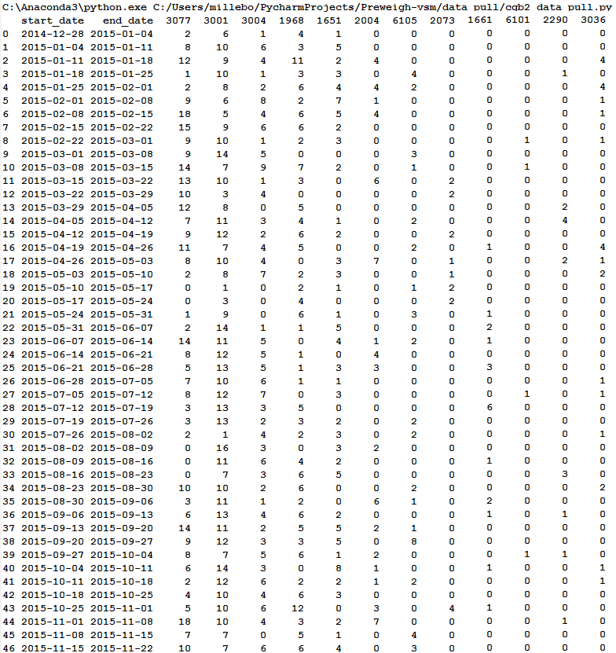

Each Bi-Weekly Period

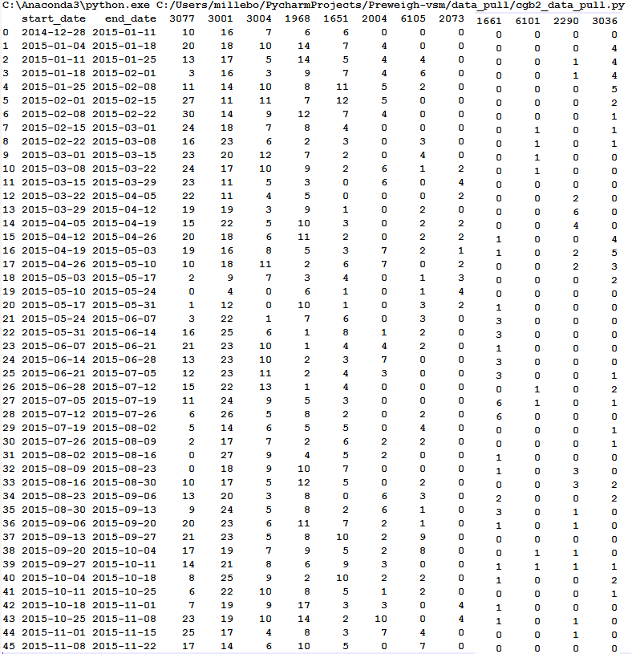

**Material Requirements**

From here, the material requirements of each composition were determined. Where available, this was taken from CGCOMPS.XLS. Otherwise, material requirements were taken from a combination of Sys and paperwork records. The dynamic components were assumed to average out to their target values.

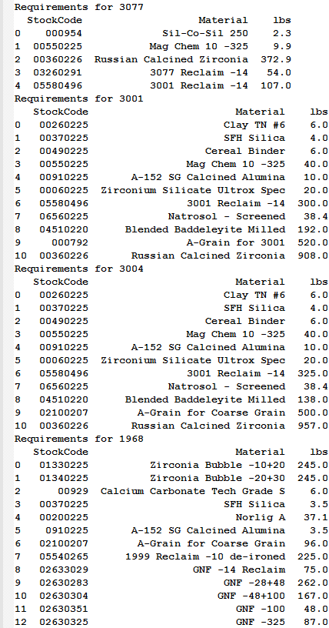 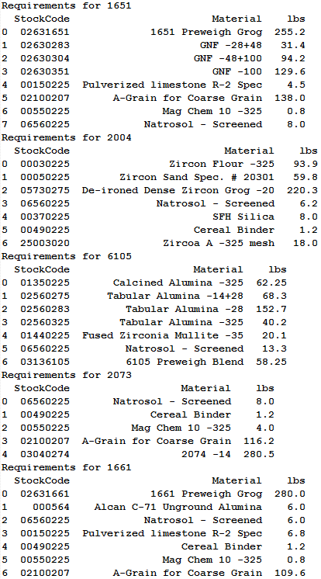

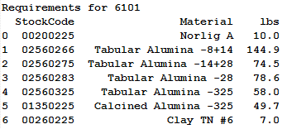 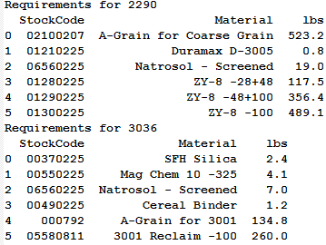

**Mapping Material Requirements**

Using Python, the materials were evaluated one at a time, and mapped to the weekly and bi-weekly production of each comp. The number of comps produced was multiplied by the pounds required per batch. If a comp did not require a material, the result was 0. Finally, a sum for each period was evaluated and appended to the dataframe.

Example: Mag Chem

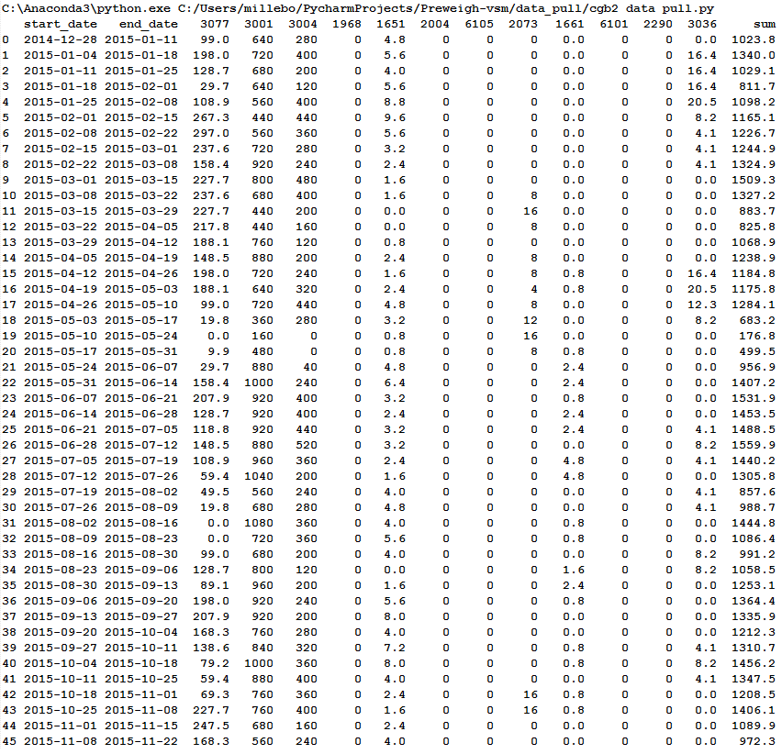

**Applying Material Usage Statistics**

The mapping was performed for each material, and statistical analysis was applied to the summed usage for each material mapping. Namely, the median, mean, and max usage was taken for each material. The results were then compiled in a new matrix:

Weekly Statistical Analysis Results:

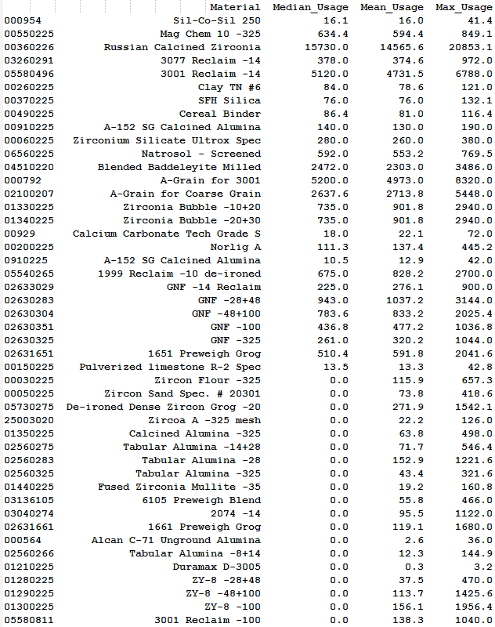

Bi-Weekly Statistical Analysis Results:

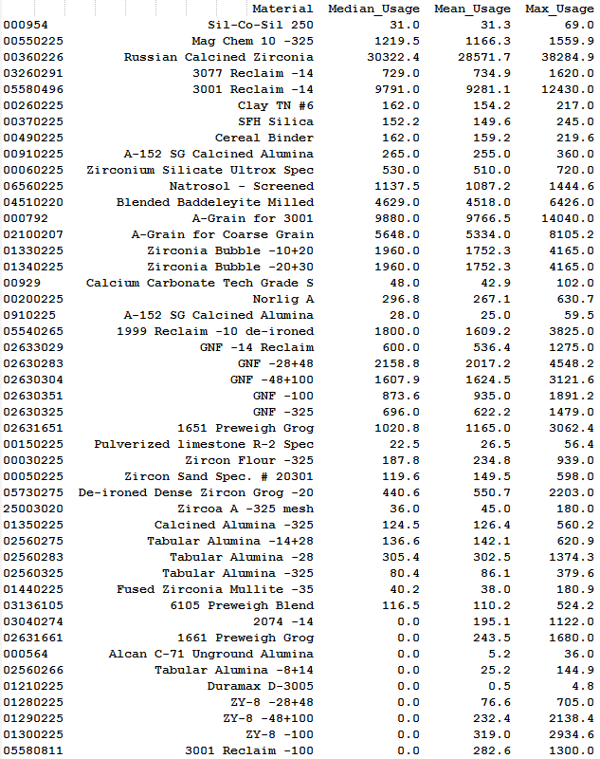

**Material Deconstruction to Containers and Pallets**

The material usage data was broken down further to look at container usage and pallet usage based on the found weight usage. Each material was mapped to its container type and pallet holdings:

Example:



Following this process finally yielded mean, median, and max pallets consumed weekly and bi-weekly for each material.

**Recommended Stocking – High and Low**

Using the material usage deconstruction, I was able to build a recommendation for high and low pallet stocking levels to apply to a new raw material supermarket system. The decision making is as follows:

Recommended Stocking - High:

1. If a material, on average (median), is not used during a two-week period, that material should not be stocked on site, and instead pulled when needed
2. If a material is used in a two week period, on average (median), we should maintain two pallets on-site
3. If the median pallet usage in a two-week period is more than the maximum pallet usage in a one-week period is, we should stock enough to cover the median two-week pallet usage (rounded up).
4. Otherwise, we should stock enough to cover the maximum pallet usage in a one-week period (rounded up).

Recommended Stock – Low:

1. If a material, on average (median), is not used during a two-week period, that material should not be stocked on site, and instead pulled when needed.
2. Otherwise, call for more material when we reach a level equal to the mean usage requirement for a one-week period (rounded up).

Note: By nature of rounding, the minimum is always 1, unless we choose not to stock the item.

**Results from Stocking Recommendations**

With these recommendations in place, we can plan for space requirements in this system. First, the pallet requirement is divided by 4, rounded up (to account for pallet-stacking). Further, we can divide by two (rounded up) to get an idea for how much space would be require if we went 2-deep on qualifying materials. The results follow:



**Not Evaluated**

Another piece that would go with this system is a milk-run inventory system, where raw material would be staged upon first arrival. No formal analysis has been performed on space requirements for this system. Instead, eight spaces was estimated as sufficient room for such a system.